Contents

- Parents’ Handbook
- Registration Forms
- Child Conduct Policy
- Complaints Policy
- Curriculum Policy
- Emergency Closure Policy
- Ethos Policy
- Health & Safety Policy
- Safeguarding & Child Protection Policy
- Staff & Volunteers Policy

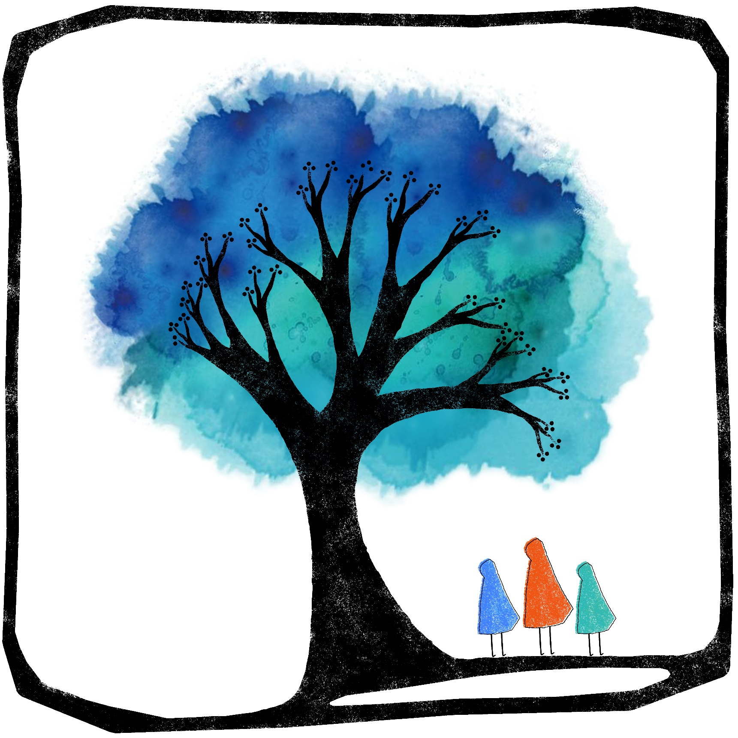
Parents’ Handbook

Introduction
You are warmly welcomed to Free Spirits: a unique, alternative, play-based learning environment offering both drop-off and family days open to parents and children of all ages. We strive to provide loving childcare and informal learning experiences in a homely, child-centred environment, with ample time to play outdoors. We will respect each child’s individuality, cater for all aspects of development and allow unpressured learning through play and exploration within a rhythmic daily structure.

Opening Hours
We operate most of the year round, with two weeks’ closure during the Christmas, Easter and Summer Holidays. Our Hygge sessions are held on Mondays, and Childcare is available on Tuesdays, Wednesdays and Thursdays. Bushcraft session are held on Thursdays, Fridays and Sundays. Our core childcare sessions run 9am-3pm with the wraparound care bookable separately. Private tutoring is available on request. Check for updates on our website and on Facebook.

Registration
Parents must complete a Registration & Permissions Form for each child before attending their first session (available on our booking platform Fienta). A one-off membership fee of £50 per family is due by the time your child attends three childcare sessions. This fee covers the admin, insurance, Ofsted and legal costs associated with providing regulated childcare.

Account Name: Free Spirits Education CIC.
Bank: Starling.
AC: 26924640
SC: 60-83-71

Our Staff
Gemma Woodhouse:  Founder, General Manager & DSL    B. Ed (Hons) Primary Education, QTS, Certificate of Waldorf Education, Certificate in Business Management  07753 620246  freespiritseducation@outlook.com | Steph:  Childcare Leader, Deputy Manager, DDSL  
Fearn:
Childcare Assistant
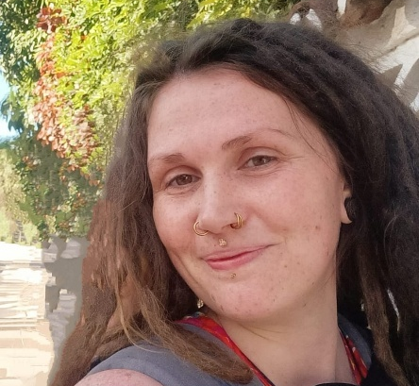
Laura:  Hygge Session Leader   | Dawn & Tracy:  In The Wild & Bushcraft Leaders  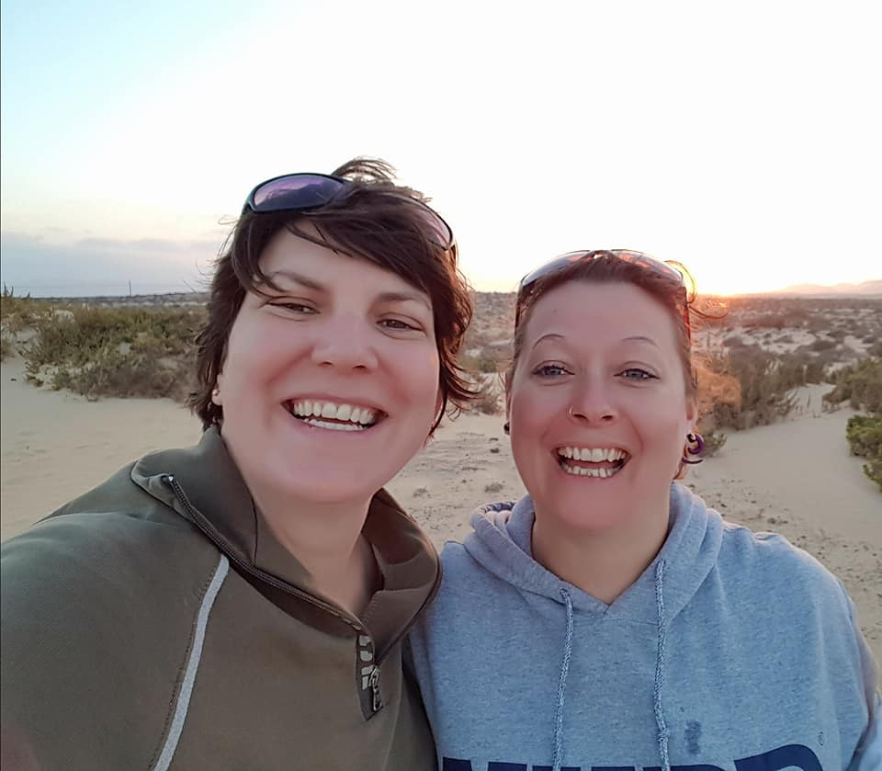

Finding Us
Address: Free Spirits, Norman Court, West Tytherley, Salisbury SP5 1NH.
Entry to the estate is only via the entrance road shown on the map. To find the car park, go past the manor house all the way to the woodland at the back. Backtrack to the Free Spirits Cabin which is opposite Blake Hall (sports hall), next to the tennis courts.
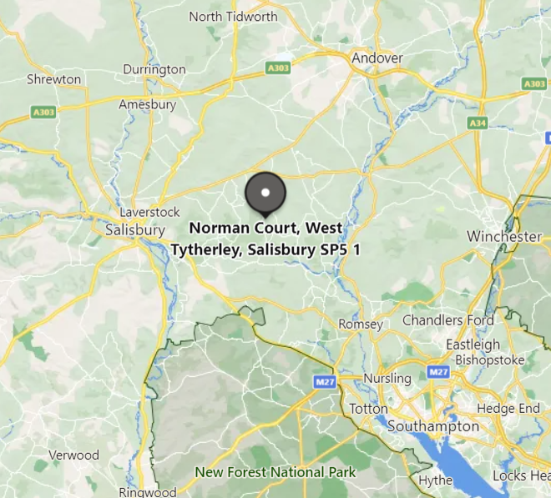
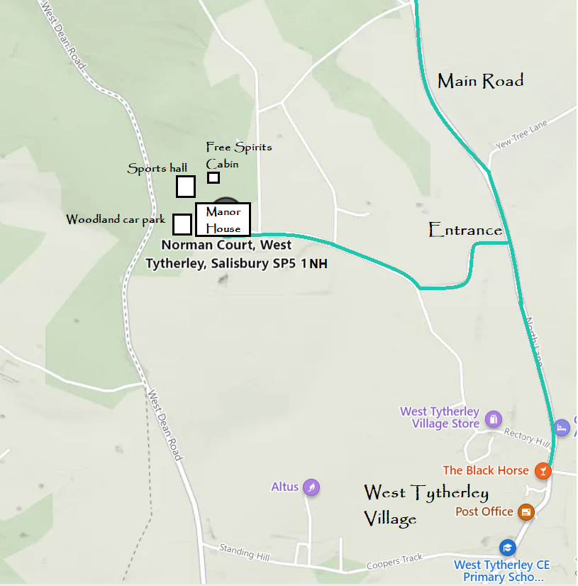
NH
​We are situated in the heart of the countryside on the Wiltshire/ Hampshire border in the picturesque village of West Tytherley. Our base is a wooden cabin with its own private garden within the grounds of Grade II listed manor house Norman Court, which benefits from 42 acres of fields and woodland, as well as infrastructure that was in place when the manor house itself was formerly used as a school.
Contact Details
Founder & Manager: Gemma Woodhouse 07753 620246
Duty phone number for staff on site: 07375 229926
freespiritseducation@outlook.com
www.freespiritseducation.com
www.facebook.com/freespiritseducationchildcare
Free Spirits, Norman Court, West Tytherley, SP5 1NH
Ofsted reg: 2671211
Community Interest Company No.13700534

Fees
Please check on Fienta, our booking platform, for our current fees. Government-funded childcare can be used at Free Spirits Education until the term after your child’s 5th birthday. This covers basic childcare, and we request that additional costs (e.g. food, specialist activities) are met by the parents. We can apply for this funding on your behalf and just need your signature on the paper form. There is also a section where you can inform us if you receive any benefits, as this may also award Free Spirits additional Early Years Pupil Premium funding to support your child. The number of days' attendance is flexible, although children should attend for the entire duration of the day that they have signed up for.

Booking
Booking links can be found at www.freespiritseducation.com/booking .This will take you to our booking platform: https://fienta.com/o/allevents.Sessions must be booked and paid for online before the beginning of the term.

Interested in Joining?
- Send us a WhatsApp or Email to request a FREE taster session.
- Book sessions online: https://fienta.com/o/allevents
- Block book a whole term (discounted), or just book ad hoc sessions.
- 15/30hrs Gov funding for under 5s.
- Tax-free Childcare and Childcare Voucher payments possible.
- Up to 85% costs refunded if in receipt of Universal Credit.
- EHCPs welcome subject to agreement.

Daily Timetable
We follow a loose rhythm that is subject to change depending on the weather, group’s mood etc.

Please ensure your child has sufficient outdoor clothing, and slippers for indoors if required (outdoor shoes must be removed before entering the cabin).

Ethos
Free Spirits is a unique combination of Steiner Waldorf, Montessori and Forest School philosophies, encompassing the common aspects of all three of these alternative education approaches.

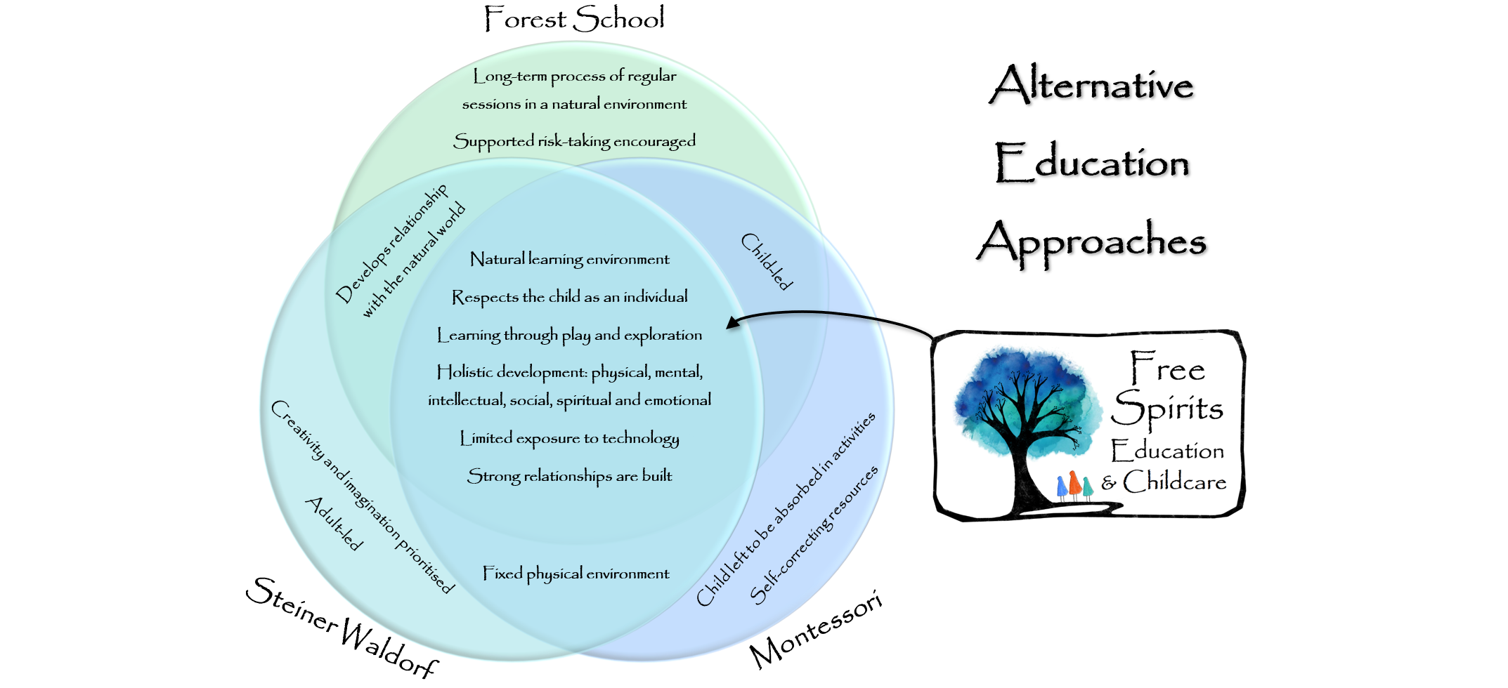
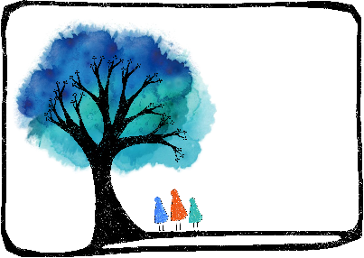
Alternative Education Approaches
Free Spirits
Steiner Waldorf Pedagogy
Steiner Waldorf education aims to provide an unhurried and creative learning environment in harmony with different phases of a child’s development. It strives to develop pupils’ intellectual, artistic and practical skills in an integrated and holistic manner. Children should have joyful childhoods and do not start formal learning until at least at 6.

Montessori Pedagogy
Montessori education is based on self-directed activity, hands-on learning and collaborative play. It should develop natural interests and activities rather than use formal teaching methods.

Forest School Pedagogy
Forest School is a child-centred learning process that offers opportunities for holistic growth through regular sessions in natural environments. It involves play, exploration and supported risk-taking, and develops confidence and self-esteem through learner-inspired, hands-on experiences in a natural setting.

What’s on & When?
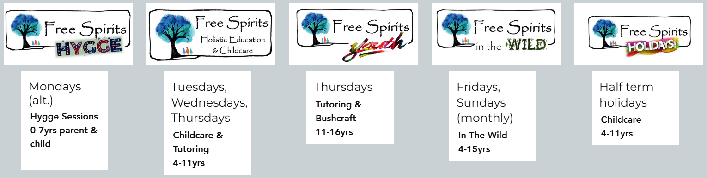
Hygge Sessions:
10am-1pm alternate Mondays. Stay and play with your preschool or home ed children aged 0-7.
Childcare & Tutoring:
9am-3pm childcare, and 1:1/small group tutoring bookable separately. For children aged approx. 4-11 (Early Years, Home Ed, Alternative Provision).
Youth:
Full/half day sessions. Choose from Tutoring or Bushcraft in the morning, and Bushcraft in the afternoon for youths aged 11-16. Option to take Functional Skills exams (GCSE equivalent).
In The Wild:
10am-3pm first Sunday of the month & third Friday of the month. Drop off or stay and play in the woods with our affiliate company offering Bushcraft and nature play. Open to children aged 4-15. Half days and sibling discounts available.
Holidays:
ALL children welcome to attend our holiday clubs (including schoolchildren).

Volunteering
Please discuss with the Manager if you would like to volunteer at the centre, and whether your intention is to be there to support your child or if you are volunteering to assist the centre as a whole under the direction of the Manager. Please also suggest how long you would like to volunteer for. Acceptance of volunteers into the setting is at the Manager’s discretion and may not always be required or appropriate. A Volunteer Record Sheet will need to be completed for regular volunteers.

An enhanced DBS certificate is required for anyone aged 16+ to work unsupervised with children. Adults who do not have a DBS certificate must be supervised at all times, and may not provide personal care to children other than their own (including eating, drinking, toileting or dressing). Staff:child ratios will be adhered to at all times as detailed in the EYFS. All staff, volunteers and visitors will have their identity checked on arrival.
​
Free Spirits Rules for Adults
- Please sign in and remove outdoor shoes when entering the cabin.
- Please do not use personal mobile phones in any areas where children are permitted.
- At family/public events, please ensure that any photos taken that include other children are kept for private use only, and are not posted on social media sites.
- Please do not offer personal care (dressing, toileting, eating) to children other than your own.
- Please do not smoke or vape anywhere on the premises.
- Please respect and help to maintain the premises.
- Please intervene in any disputes between children fairly and respectfully, encouraging the children involved to problem-solve together rather than dictating a solution.
- Adults should behave in a manner that is calm, gentle, polite and worthy of imitation.
- Support your children to treat everything on the premises with responsibility and respect.
- Support your children to help with the daily running of the day, such as preparing food, washing up, tidying and cleaning the cabin.

Free Spirits Education believes in working in close partnership between parents. In order to allow each child to engage fully with the education we offer, we ask parents to:
- Complete the Registration & Permissions Form before the child’s first attendance
- Provide healthy rhythms for the child: a healthy diet, ensure adequate sleep, and limit access to screen devices
- Support their child in adhering to the Child Conduct Policy
- Provide suitable clothing and equipment for the child
- Show an active interest in the child’s education
- Attend meetings as requested
- Discuss any concerns with the session leaders promptly
- Inform the centre of any changes in circumstances that may affect their child’s behaviour
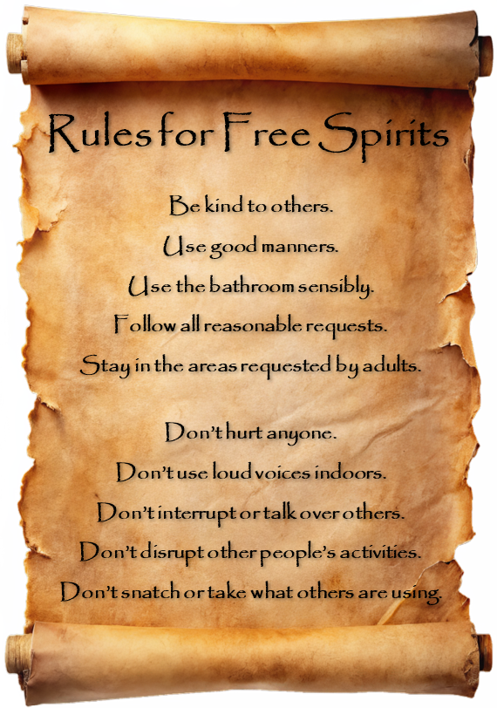
- Adhere to the agreed drop-off and collection times for your child

Concerns and Complaints
If you have a concern regarding Free Spirits Education, please discuss it with the Manager in the first instance. We will take all concerns seriously and make every effort to resolve them. A face-to-face conversation is usually most efficient, but if you prefer, you can phone 07753620246 or email freespiritseducation@outlook.com.

Please state if you are making a formal written complaint and send it by letter or email. We will keep a written record of any complaints, and their outcome. We are required by Ofsted to investigate written complaints relating to our fulfilment of the EYFS requirements and notify complainants of the outcome of the investigation within 28 days of having received the complaint.

If the complaint cannot be resolved or is of a serious nature, you can contact Ofsted on 0300 1231231.

Whistleblowing
All staff can raise concerns about poor or unsafe practice and potential failures in the school safeguarding regime. If your concern is about the Manager/DSL, contact:
Hampshire County Council’s Local Authority Allegation Designated Officer (LADO):
Phone 01962 876364
Email child.protection@hants.gov.uk
https://www.hants.gov.uk/socialcareandhealth/childrenandfamilies/safeguardingchildren/allegations
If you feel your safeguarding concerns are not being addressed, you can contact the NSPCC whistleblowing advice line:
0800 028 0285 from 08:00 to 20:00, Monday to Friday, or email help@nspcc.org.uk

Policy Information
Free Spirits Education CIC has the following policies which explain what we believe and how we will implement these beliefs:
- Child Conduct Policy
- Complaints Policy
- Curriculum Policy
- Emergency Closure Policy
- Ethos Policy
- Health & Safety Policy
- Safeguarding & Child Protection Policy
- Staff & Volunteers Policy

Parents may wish to familiarise themselves with these policies and procedures. They are found on the centre website www.freespiritseducation.com and are also available on request by email.

TERMS AND CONDITIONS OF CHILDCARE
1. A non-refundable registration fee of £50 (per family, not per child) is due by the time the child has attended three childcare sessions. This fee covers the admin, insurance, Ofsted and legal costs associated with providing regulated childcare, and covers making all the registration arrangements for your child.
2. We cannot look after your child until we have received a completed Registration & Permissions form.
3. In order to use our services, customers must book and pay for all session types at least 24 hours in advance using the Fienta booking platform. Please use this automated system whenever possible, rather than direct contact, in order to relieve staff administrative burden.
4. Tickets are non-refundable. You may transfer your booking from one session to another within the same term provided you give 7 days' notice.
5. No refund will be given in the event of a child’s absence due to illness, holiday or for any other reason. This is because we have to reserve a place for the child with appropriate staffing in advance.
6. Please drop off and collect your child at the agreed times. You will be charged for one hour's wrap-around childcare if your child is collected more than 10 minutes late. This is because staff have to be paid to work additional, unexpected hours. Please contact the Duty Phone to inform us of child absences or any other issues relevant to the day: 07375 229926
7. Once your child has been registered for a childcare place at Free Spirits, we will assume regular ongoing attendance until withdrawal, for which we require one month's notice by email.
8. Parents utilising the Government 15/30 hours' free childcare are encouraged to authorise at least 12 hours of funding per week (equivalent to two days' core hours attendance per week). This is due to the ongoing administrative burden of applying for such funding and the below-cost fees offered by the funding.
9. Adults on the premises must behave in a manner that is calm, gentle, polite and worthy of imitation. Please refrain from using potentially offensive language (this also extends to your children).
10. Children are expected to treat everything on the premises with responsibility and respect.
11. Please do not leave children who are too unwell to cope with our ordinary day-to-day activities as we cannot provide 1:1 care.
12. Parents may stay with their child for up to an hour during the child's first three settling-in sessions if necessary. Thereafter, parents dropping off children must leave the premises within 5 minutes in order to prevent a build-up of separation anxiety. Our experienced staff will care for your child and send you updates on their wellbeing if requested.
13. Please send your child with a suitable lunch, drinks bottle, a change of clothing (named), appropriate footwear and seasonal hat if the weather is very hot or cold.
14. Children may not bring toys or other precious items from home into Free Spirits, as monitoring of such items places an additional burden on staff.
15. Free Spirits cannot be held liable for the loss or damage of any item belonging to the public on the premises.
16. As the ethos of Free Spirits follows child-led holistic development, as long as children are complying with our conduct expectations and their welfare is not compromised, we allow children to respond to their natural instincts for example removing their own clothes for outdoor water play in warm weather (in the private Free Spirits gardens only), barefoot exploration of risk assessed areas, sensory exploration and 'messy play' such as with mud, sand, paint etc.
17. By utilising childcare at Free Spirits, you understand and permit that, as part of their development, we may allow your child to engage in risky activities such as climbing, balancing, jumping, cooking etc. and using potentially dangerous equipment such as scissors, knives, saws, hammers, fire, sticks, ropes etc. Children may experience other elements of risk such as contact with animals, exploration of the natural world and crossing roads. All risky activities will be risk-assessed either formally or informally, and will be suitably supervised.
18. By utilising childcare at Free Spirits, you give consent for your child to be taken on foot to other areas of the Norman Court estate and village of West Tytherley.
19. By presenting your child for any kind of session offered at Free Spirits, you and all those with parental responsibility over your child release and discharge Free Spirits from any and all liability, claims or causes of action, in the absence of gross negligence, that may arise during or as a result of your child's attendance and participation.
20. All our policies can be viewed on our website at www.freespiritseducation.com.

Childcare Registration

Parent 1 Full Name (primary carer)
Parent 1 Occupation
Parent 2 Full Name (& address if different from child’s)
Parent 2 Occupation
Parent Email Address
Parent Phone Number
Child’s Full Name
Child’s Date of Birth
Child’s Nationality
Address (child’s primary residence)

Allergies, Dietary Requirements, Medical Needs, SEND etc.

Emergency Contact Details (min. 2 names and phone numbers)

Collection Authorisation (list all people who may collect your child)
Is your child involved with Social Services/Paediatrician Services?
Parent ID seen (if Early Years):
Child’s birth certificate presented (if Early Years): | Original / photocopy / electronic image

Registration Fee
A one-off registration fee of £50 per family is due after your child attends three childcare sessions. This fee covers the admin, insurance, Ofsted and legal costs associated with providing regulated childcare. Account Name: Free Spirits Education CIC. Bank: Starling. AC: 26924640 SC: 60-83-71

Permissions

- I give permission for my child to have first aid administered by Free Spirits staff as and when required: YES/NO

- I give permission for my child to have sun cream applied by Free Spirits staff as and when required: YES/NO

- I give permission for my child to be taken to hospital and/or have emergency paramedic treatment as and when required: YES/NO

- I give permission for Free Spirits staff to take identifiable photographs/videos of my child for use on company media e.g. the Facebook page, website, which will not bear the children’s name: YES/NO

- I have read and agree to abide by the Terms and Conditions: YES/NO

Please add any relevant information here (even if included on the Registration Form) e.g. relating to allergies, first aid, medical conditions, use of photographs/videos etc:

Signed:_________________________ Relationship to child:__________________

Print name:_______________________________ Date:_____________________

Our Policies

- Child Conduct Policy
- Complaints Policy
- Curriculum Policy
- Emergency Closure Policy
- Ethos Policy
- Health & Safety Policy
- Safeguarding & Child Protection Policy
- Staff & Volunteers Policy

Child Conduct Policy

This policy outlines how we expect children at Free Spirits Education to conduct themselves, and how this will be reinforced. It is deliberately named a ‘conduct policy’ rather than a ‘behaviour policy’ on the understanding that children’s behaviour is an expression of communication. We believe that communication is to be encouraged rather than suppressed, alongside socially acceptable means of expression and a good general manner that is conducive to a harmonious environment.

Creating a harmonious environment
Staff are responsible for setting the tone of the environment and will (as detailed in the Staff Policy) conduct themselves as models worthy of imitation, with a generally calm and gentle demeanour and good manners. Staff interactions with children should be based on sensitive and professional observation, responding to each child’s emerging needs and guiding their development through warm, positive interactions coupled with secure routines for play and learning.

We will avoid placing unreasonable demands on children that are inappropriate to their age, developmental stage or emotional state, as this can result in displays of frustration from the children. An example of an unreasonable demand would be insisting that young children sit still listening to the teacher talk for too long. If children begin to display signs of frustration, staff will evaluate what modifications they can make to the task or the environment.

Behaviour management techniques at Free Spirits Education are in line with those endorsed by Adele Faber & Elaine Mazlish (co-authors of ‘How to talk so kids will listen, and how to listen so kids will talk’) and Sarah Ockwell-Smith (author of ‘The gentle parenting book’).

Expectations of children
Children attending Free Spirits Education will be expected to conduct themselves in a pleasant manner appropriate to their developmental stage, being kind and considerate towards other children and adults whilst feeling able to express themselves with authenticity. For example, if Child A is enjoying playing alone with a toy and Child B wishes to have it, Child A will not be forced to share or yield the toy as we respect their right to continue pursuing their interests. Instead, Child A will be encouraged to politely express their wishes whilst also collaborating with Child B to reach a mutually acceptable solution, e.g. to hand over the toy after a short period of time. Likewise, children will not be forced to display inauthentic emotional behaviours such as returning an unwanted hug from another child, but they will be expected to remain courteous.

Good manners will be expected at all times, which will also be modelled by staff, as young children learn best by imitation. Children will be shown gratitude and appreciation for kind and considerate behaviour, but will not be rewarded excessively, as good conduct should be seen as the norm.

Responding to incidents
We embrace restorative approaches to support the maintenance and repairing of relationships and actively promote emotional literacy. In the event of a dispute between children that requires adult intervention to avoid escalation, both parties will be listened to and encouraged to problem-solve together in order to reach a compromise without prioritising the needs of either child. Children will be encouraged to express their feelings whilst maintaining responsibility for them e.g. “I feel disappointed because you won’t give me that toy” rather than the accusatory, “You have made me sad because you won’t give me that toy”.

Staff will seek to understand the cause of unacceptable behaviour and provide appropriate support. Any intervention will not be based on punishing a child, but rather on protecting other children and helping children to learn how to express themselves appropriately. For example, a child who is causing disruption to others will be taught about the impact that their actions may have on others and an alternative behaviour advised, and may be guided towards an alternative activity. They may be invited to have some ‘time in’ with an emotionally available adult, or ‘time out’ if they would prefer to be alone to work through their feelings.

Child-on-child Abuse (including Bullying)
All child-on-child abuse is unacceptable and will be taken seriously. Examples include bullying (including cyber bullying), gender-based violence, sexual assaults and sexting.

Staff will minimise the risk of peer-on-peer abuse by:
- Encouraging positive relationships between children
- Encouraging children to develop a positive self-image
- Educating children on rights, respect and responsibilities
- Providing a relevant curriculum that helps children to develop their understanding of acceptable behaviours, healthy relationships and keeping themselves safe
- Encouraging the children to raise concerns with staff
- Listening to children and taking their worries seriously
- Staff vigilance and early intervention to prevent low level behaviours from becoming abusive experiences

We will respond to incidents by:
- Making children aware when their behaviour towards another child is unacceptable
- Redirecting the perpetrator to more acceptable behaviours
- Challenging all contact behaviours that have a sexual nature to them such as pushing or rubbing against, grabbing bottoms, breasts or genitals, pinging or flicking bras, lifting skirts, pulling down trousers and upskirting (photographing under a person’s clothing) or precursors to upskirting such as attempting to view underwear or genitals, and imposing appropriate levels of disciplinary action such as removing the perpetrator from the situation, to make clear that these behaviours are not tolerated or acceptable
- Providing support to victims of sexual violence and sexual harassment and ensuring that they are kept safe
- The adult should reassure the child and listen without interrupting if the child wishes to talk
- The observed instances will be detailed in a confidential report
- The observed instances will be reported to the centre Manager
- A sensitive and confidential discussion will be held with the parents of both parties (unless this would put a child at greater risk)
- If the child is at risk of harm, is in immediate danger, or has been harmed, a referral will be made to the local authority children’s social care team

Special Educational Needs
As our approach is child-centred and based on children’s needs, developmental stage and emotional state, Free Spirits Education aims to be accessible to the majority of children operating within our intended developmental range of 4-11 years. We favour the Steiner Waldorf Early Years Curriculum, which supports and values the benefits of an unfettered childhood and allows children to be the ‘free spirits’ that they are, rather than seeking to institutionalise them. The children are not rushed or over-stimulated and are allowed space to develop physical coordination and personal, social and cognitive skills.

However, if your child requires a higher level of adult assistance or intervention than we are normally able to provide, we respectfully suggest that Free Spirits may not be the right environment for them thrive. We can cater for certain children with SEN or an EHCP (subject to agreement), but we do not provide 1:1 support, nor can we cater for children who cannot abide by our rules for the majority of the time.

Child Conduct Policy - Appendix

Children with co-operation difficulties
Most children respond positively to ordinary requests made by our staff to carry out certain tasks, move from one area to another or display good manners. However, some children may be unused to the expectation that they must comply with reasonable requests and instructions issued by adults responsible for them, or they may have particular SEN such as PDA (Pathological Demand Avoidance) which makes following direct requests distressing.

This Appendix outlines our behaviour management strategies that, in consultation with the child’s parents and any successful EHCP in place, we intend to implement with children who require a different approach.

What will staff do if children do not comply with reasonable requests?
We will endeavour to follow these sequential steps of positive rather than punitive behaviour management:

Approach | Example
Allow the benefit of the doubt – perhaps the child didn’t understand or didn’t hear – and politely repeat the request. | “Please could you put your tissue in the bin?”
Use low-demand, declarative language. | “The bin for your tissue is over there.”
Assume the child did not realise that the request was compulsory rather than optional – repeat the request and gently make the correct course of action clear. | “I’d like you to put your tissue in the bin, thank you.”
Adopt a firmer tone and sense of importance. | “I need you to put your tissue in the bin.”
Explain the reason for/importance of the request. | “Dirty tissues can spread germs. We are all responsible for our own litter. I don’t want it to be left on the floor.”
Playfully suggest a fun way to carry out the request. | “I wonder if you can throw the tissue in the bin from here?”
Provide options for how the request is carried out. | “Do you want to put the tissue in the kitchen bin, or the bathroom bin?”
Offer assistance or a compromise. | “Shall I bring the bin closer to you?”  “Shall I give you a few minutes then come back and see how you’re getting on?”  “Do you want to do it now, or in five minutes?”
Explain that the child will not be permitted to move on to any other activity until the requested task has been completed. | “I understand that you don’t want to put your tissue in the bin, but you won’t be allowed to go and play until you’ve done it.”  Reinforce this by preventing access to toys/other areas by path-blocking or removing toys near child. Path-blocking with a minimal degree of restraint is particularly important if it appears that the child might try to do something potentially unsafe e.g. leave the building, jump from a high place.
Remind the child of the benefit of complying. | “You can go and play as soon as you’ve put your tissue in the bin!”
Accept that the request is impossible for the child to comply with. | “I can see you’ve really struggled with this. I’ll show you how to do it and hopefully next time you’ll be able to do it.”

Complaints Policy

Concerns and Complaints
If you have a concern regarding Free Spirits Education, please discuss it with the Manager in the first instance. We will take all concerns seriously and make every effort to resolve them. A face-to-face conversation is usually most efficient, but if you prefer, you can phone 07753620246 or email freespiritseducation@outlook.com.

Please state if you are making a formal written complaint and send it by letter or email. We will keep a written record of any complaints, and their outcome. We are required by Ofsted to investigate written complaints relating to our fulfilment of the EYFS requirements and notify complainants of the outcome of the investigation within 28 days of having received the complaint. The following information will be recorded:

- The name of the person making the complaint
- The Early Years Foundation Stage requirement(s) to which the complaint relates
- The nature of the complaint
- The date and time of the complaint
- Any action taken in response to the complaint
- The outcome of the complaint investigation (e.g. how the centre has improved)
- Details of the information and findings that were given to the complainant, including any action taken
If the complaint cannot be resolved or is of a serious nature, you can contact Ofsted on 0300 1231231.

Whistleblowing
All staff can raise concerns about poor or unsafe practice and potential failures in the school safeguarding regime. If your concern is about the Manager/DSL, contact:
Hampshire County Council’s Local Authority Allegation Designated Officer (LADO):
Phone 01962 876364
Email child.protection@hants.gov.uk
https://www.hants.gov.uk/socialcareandhealth/childrenandfamilies/safeguardingchildren/allegations

If you feel your safeguarding concerns are not being addressed, you can contact the NSPCC whistleblowing advice line:
0800 028 0285 from 08:00 to 20:00, Monday to Friday, or email help@nspcc.org.uk

Curriculum Policy

Free Spirits Education is an independent education centre, although we are obliged to join Ofsted’s Compulsory Childcare Register (for providers for children aged 5-8) and the Early Years Register (for providers for children aged up to 5) in order to ensure that all safeguarding, welfare and learning and development requirements are met. As such, we follow and are inspected on the Early Years Foundation Stage (EYFS) statutory framework, which states:

Four guiding principles should shape practice in early years settings:

Every child is unique
Positive relationships
Enabling environments and adults
Learning and development

Characteristics of effective teaching and learning:

Playing and exploring
Active learning
Creating and thinking critically

The EYFS specifies requirements for learning and development, and the chart below exemplifies how these are delivered at Free Spirits Education:

The 7 Areas of Learning and Development and the Educational Programmes

EYFS Areas of Learning & Development | Activities & Experiences | Examples of how Free Spirits Education provides these
- Communication & Language | - Conversations with adults & peers  - Building vocabulary  - Reading books to children  - Storytelling, non-fiction, rhymes & poems  - Role play | - Adults mindful of language used, using ambitious, non-patronising vocabulary  - Sociable meal times around a table encouraging conversation  - Books often read to and with children  - Frequent oral language enjoyment during Circle Time e.g. rhymes and songs  - Role play area in the classroom
- Physical Development | - Gross motor: agility, balance, co-ordination & strength  - Fine motor: small word play, puzzles, crafts & tool use | - Daily opportunities for physical play indoors and out, using a range of equipment  - Daily opportunities for playing and crafting with small items  - Gardening, food preparation, cleaning, handiwork, trying on dressing up items
- Personal, Social & Emotional Development | - Strong relationships with adults  - Adults as role models  - Managing own emotions  - Positive self-image  - Setting goals & persisting  - Looking after self  - Co-operating with other children | - Adults act through love for children  - Adults behave worthy of imitation and are courteous  - Children regularly praised and encouraged  - Positive behaviour management techniques used  - Children encouraged to be independent  - Children take responsibility for caring for the classroom  - Sociable, convivial meal times around a table  - Circle time and sharing opportunities  - Familiar routines and transitions
- Literacy | - Enjoying books, stories, rhymes, poems & songs  - Reading: decoding and recognising  - Writing: oral composition, spelling & handwriting | - Range of literature regularly enjoyed with children  - Frequent oral language enjoyment during Circle Time  - Natural opportunities for reading and writing frequently exploited during daily activities and play  - Signs and labels in the environment used as examples of text  - Games, puzzles and activities available for learning about the reading and writing of letters and sounds
- Mathematics | - Counting & understanding numbers to 10  - Using counting resources  - Space, shape & measures | - Natural opportunities for counting and measuring frequently exploited during daily activities and play  - Food preparation – weighing, measuring, sorting, comparing, counting out crockery and cutlery  - Natural resources in the environment used as opportunities to practise counting and assessing space, shapes and measures  - Games, puzzles and activities available for learning about quantities, space, shapes and measures  - Number and counting songs
- Understanding the World | - Understanding our physical world  - Understanding community & society  - Broad variety of stories, books & experiences | - Mindfulness of and reverence for our immediate environment encouraged, indoors and out  - Meal time discussions draw on children’s outside experiences of their community and society  - Activities and crafts draw upon seasonal influences and celebrations from a range of cultures  - Use of natural materials  - Exploring immediate garden and woodland surroundings
- Expressive Arts & Design | - Exploring & playing with a range of media & materials  - Communicating through the arts | - Regular opportunities to participate in crafting and creative activities in 2D and 3D forms  - Opportunities for self-expression through music, role-play and dance  - Explore and be creative with natural materials

Special Educational Needs
Free Spirits is an inclusive setting that enables all children, including those with additional special educational needs and disabilities (SEND), to reach their full potential. We support equality of opportunity for all children in our care. Our approach is child-centred and based on children’s needs, developmental stage and emotional state, and as such we aim to be accessible to the majority of children operating within our intended developmental range of 4-11 years. Our curriculum supports and values the benefits of an unfettered childhood and allows children to be the ‘free spirits’ that they are. They are not rushed or over-stimulated and are allowed space to develop physical coordination and personal, social and cognitive skills.

By working in partnership with children, parents and carers, we are continually developing our provision to ensure we meet the needs of every child that is entrusted to us. We consider each child when planning and setting up our provision to ensure our curriculum is accessible to all. We acknowledge that some children will require additional support and where appropriate a range of strategies are implemented in agreement with parents / carers.

However, if a child requires a higher level of adult assistance or intervention than we are normally able to provide, we respectfully suggest that Free Spirits may not be the right environment for them thrive. We can cater for most children with SEN or an EHCP (subject to agreement), but we do not provide 1:1 support, nor can we cater for children who have behavioural issues and cannot abide by our rules for the majority of the time.

Assessment
Free Spirits Education does not have to conduct the Reception Baseline Assessment as we are a private education centre rather than a maintained school. We do, however, have to complete the Early Years Foundation Stage Profile by 30th June in the academic year in which children turn 5. This Profile simply states whether or not the child has met the 17 Early Learning Goals as detailed in the EYFS. Children will be assessed through observation and collaboration rather than through formal assessment procedures. We believe it is more important and useful to really get to know your child well than to have to rely on contrived assessment methods. If your child transfers to Year 1 in a maintained school, their teacher must be given the Profile report.

Early Years Foundation Stage Profile  Attainment against the Early Learning Goals (ELG) | Yes | No
Communication & Language
Listening and Attention
Children listen attentively in a range of situations. They listen to stories, accurately anticipating key events and respond to what they hear with relevant comments, questions or actions. They give their attention to what others say and respond appropriately, while engaged in another activity.
Understanding
Children follow instructions involving several ideas or actions. They answer ‘how’ and ‘why’ questions about their experiences and in response to stories or events.
Speaking
Children express themselves effectively, showing awareness of listeners’ needs. They use past, present and future forms accurately when talking about events that have happened or are to happen in the future. They develop their own narratives and explanations by connecting ideas or events.
Physical Development
Moving and Handling
Children show good control and co-ordination in large and small movements.
They move confidently in a range of ways, safely negotiating space. They handle equipment and tools effectively, including pencils for writing.
needs successfully, including dressing and going to the toilet independently.
Health and Self-care
Children know the importance for good health of physical exercise, and a healthy diet, and talk about ways to keep healthy and safe. They manage their own basic hygiene and personal
Personal, Social and Emotional Development
Self-confidence and Self awareness
Children are confident to try new activities, and say why they like some activities more than others. They are confident to speak in a familiar group, will talk about their ideas, and will choose the resources they need for their chosen activities. They say when they do or don’t need help.
Managing Feelings and Behaviour
Children talk about how they and others show feelings, talk about their own and others’ behaviour, and its consequences, and know that some behaviour is unacceptable. They work as part of a group or class, and understand and follow the rules. They adjust their behaviour to different situations, and take changes of routine in their stride.
Making relationships
Children play co-operatively, taking turns with others. They take account of one another’s ideas about how to organise their activity. They show sensitivity to others’ needs and feelings, and form positive relationships with adults and other children.
Literacy
Reading
Children read and understand simple sentences. They use phonic knowledge to decode regular words and read them aloud accurately. They also read some common irregular words. They demonstrate understanding when talking with others about what they have read.
Writing
Children use their phonic knowledge to write words in ways which match their spoken sounds. They also write some irregular common words. They write simple sentences which can be read by themselves and others. Some words are spelt correctly and others are phonetically plausible.
Mathematics
Numbers
Children count reliably with numbers from one to 20, place them in order and say which number is one more or one less than a given number. Using quantities and objects, they add and subtract two single-digit numbers and count on or back to find the answer. They solve problems, including doubling, halving and sharing.
Shape Space and Measures
Children use everyday language to talk about size, weight, capacity, position, distance, time and money to compare quantities and objects and to solve problems. They recognise, create and describe patterns. They explore characteristics of everyday objects and shapes and use mathematical language to describe them.
Understanding the World
People and Communities
Children talk about past and present events in their own lives and in the lives of family members. They know that other children don’t always enjoy the same things, and are sensitive to this. They know about similarities and differences between themselves and others, and among families, communities and traditions.
The World
Children know about similarities and differences in relation to places, objects, materials and living things. They talk about the features of their own immediate environment and how environments might vary from one another. They make observations of animals and plants and explain why some things occur, and talk about changes.
Technology
Children recognise that a range of technology is used in places such as homes and schools. They select and use technology for particular purposes.
Expressive Art and Design
Exploring and Using Media and Materials
Children sing songs, make music and dance, and experiment with ways of changing them. They safely use and explore a variety of materials, tools and techniques, experimenting with colour, design, texture, form and function.
Being Imaginative
Children use what they have learnt about media and materials in original ways, thinking about uses and purposes. They represent their own ideas, thoughts and feelings through design and technology, art, music, dance, role play and stories.

The Curriculum
The Curriculum at Free Spirits Education is largely based on the Steiner Waldorf Early Years Curriculum, which supports and values the benefits of an unfettered childhood and allows children to be the ‘free spirits’ that they are, rather than seeking to institutionalise them. The children are not rushed or over-stimulated and are allowed space to develop physical coordination and personal, social and cognitive skills. The focus is on child-led play with simple props to encourage creativity, ingenuity and problem-solving skills. For example a block of wood could be a ship, a telephone, or a loaf of bread.

Free play is interwoven with more structured, hands-on activities with an emphasis on domestic, artistic and craft activities to emulate a lively extended family where children can learn through imitation – the easiest and most natural way for the young child to learn. They sing, paint, draw and move to music. They listen to stories told by the teacher, create puppet shows and little plays; bake, cook and help prepare their daily snack. They plant and harvest and tend the gardens; weave, sew and use simple tools.

The patterns and routines of the day run through the week and the year and many of the activities following the cycle of the seasons and the celebration of festivals. The Early Years curriculum is based on the understanding that:
- imitation and activity are the young child’s natural way of learning
- activities aim to develop gross motor skills, speech, awareness of others and self-regulation
- collaboration in play, the sharing of food and other activities promote social development
- experiencing the natural world and sharing responsibility for such things as the care of their environment, for cleaning and tidying and for the preparation of food fosters responsibility, respect and self-reliance
- participation in the celebration of festivals inspires a sense of awe and reverence.

Structure of the Day
We follow the Steiner Waldorf philosophy of the three Rs: rhythm, repetition and reverence.

Regular patterns of activities create routine and foster a sense of security and self-confidence and help the child to know what to expect. Working with rhythm helps children to live with change, to find their place in the world, and to begin to understand the past, present and future. It provides a very real foundation for the understanding of time – what has gone before and what will follow – and helps children to relate to the natural and the human world. Children’s memories are strengthened by recurring experiences: daily, weekly and yearly events (such as festivals and celebrations) are remembered and often eagerly anticipated a second time around. Repetition helps to support good habits, and emphasis is given to regular patterns of activities repeated within the day, week and year to provide rhythm and routine. Each day has its own rhythms, which support the day’s activities. Stories, songs, verses and craft activities relate to the season and a ‘seasonal area’ in the room reflects the changing natural world throughout the year, as do the themes of the songs, stories and poems.

Emergency Closure Policy

This policy is regarding the unexpected closure of Free Spirits when otherwise advertised as being open for business. Parents will be notified of closure via WhatsApp and/or text message.

Possible Reasons for Emergency Closure
- Adverse weather e.g. strong winds, snow, icy roads or extreme heat (please note, the main driveway into the estate is gritted in icy weather by the groundskeeper)
- Staffing issues e.g. all staff are too unwell to work
- Premises issues e.g. roof collapse, fire
- Government-ordered closure e.g. due to a pandemic
- Ofsted-ordered closure e.g. due to investigation of a health and safety concern

Payment and Refunds
If the Manager has ordered the closure, clients will be reimbursed the cost of their session.

If clients decide not to come or are unable to come for whatever reason but Free Spirits is open, clients will still have to pay for that session.

If the Government, Ofsted or other regulatory body orders an unexpected closure, 50% of normal fees will still be payable by clients and the other 50% will be refunded.

Ethos Policy

Free Spirits is a unique combination of Steiner Waldorf, Montessori and Forest School philosophies, encompassing the common aspects of all three of these alternative education approaches. ‘Alternative education’ means education which differs from mainstream pedagogical approaches. We strive to provide natural learning experiences for children that will respect them as individuals, cater for all aspects of development and allow learning at each child's pace. Children will learn through play, exploration, discovery and imaginative experiences, with plenty of time spent outdoors, in an aesthetically pleasing, ergonomic environment.
Alternative Education Approaches
Free Spirits

Steiner Waldorf Pedagogy
The Founder of Free Spirits built on her four-year Batchelor of Education degree by studying a Diploma in Steiner Waldorf Education.

Steiner Waldorf education aims to provide an unhurried and creative learning environment in harmony with different phases of a child’s development. It strives to develop pupils’ intellectual, artistic and practical skills in an integrated and holistic manner. Children should have joyful childhoods and do not start formal learning until at least at 6. Roughly half of all UK alternative schools are Steiner Waldorf schools.

Rudolf Steiner’s priority was to educate children in a way that enabled them to become their true selves, to be good citizens, to contribute to society and be a strong force for good in the world. He recommended that to enable this it was important take account of the age and stage of development of each child in deciding what and how to teach them. For example, in early years children learn best through imitation and play. Steiner also recommended the integration of the arts and physical movement in all learning and to give them equal status to academic learning in order to create a well-balanced, multi-skilled, robust and emotionally strong adult.

The Steiner Waldorf ethos generally discourages children’s use of electronic media such as television, computers and mobile phones. There are a variety of reasons for this: Waldorf educators believe that use of these conflicts with young children's developmental needs, media users may be physically inactive, media may be seen to contain inappropriate or undesirable content, and it may hamper the imagination. As such, Free Spirits Education is a screen-free environment, and we would encourage parents to reflect this practice at home.

Montessori Pedagogy
Montessori education is based on self-directed activity, hands-on learning and collaborative play. It should develop natural interests and activities rather than use formal teaching methods.

Forest School Pedagogy
Forest School is a child-centred learning process that offers opportunities for holistic growth through regular sessions in natural environments. It involves play, exploration and supported risk-taking, and develops confidence and self-esteem through learner-inspired, hands-on experiences in a natural setting.

Curriculum
Our separate Curriculum Policy outlines the EYFS requirements for learning and development and how we meet those requirements at Free Spirits. As our approach is child-centred, it is suitable for both neurotypical and neurodivergent children, including those with SEND.

Health and Safety Policy

In case of emergency
Dial 999
The address is:
Free Spirits Education Cabin, Norman Court, West Tytherley SP5 1NH
What3words locations:
Cabin – grit.mixing.goal
Main car park/entrance to woodland – longer.seating.pupils
Field play equipment – vans.goggles.motivate

Free Spirits Education CIC is committed to upholding excellent levels of health and safety in order to safeguard the health and wellbeing of all our staff, volunteers and children. To ensure this, we are committed to:

- providing adequate control of the health and safety risks arising from our activities through a risk assessment process
- consulting with our workers on matters affecting their health and safety
- providing and maintaining safe premises and equipment
- ensuring all workers are competent to do their tasks, and to give them adequate training, instruction and supervision
- preventing accidents and cases of work-related ill health
- maintaining appropriate insurance

Employees and volunteers
Staff are employed using Safer Recruitment procedures as detailed on the Staff Policy. All workers have an obligation to take reasonable care for their own health and safety, and for that of others, and to co-operate with Free Spirits Education with respect to health and safety matters. Workers are requested to adhere to the separate Staff Policy outlining obligations regarding visitors, supervising, caring for and releasing children, record-keeping, smoking and vaping, alcohol and medicines, food and hygiene, promotion of good health, mobile phones and cameras, and also to:

- Report any significant hazard or malfunction (e.g. trip hazards or broken equipment) to the Manager
- Conform to all instructions, written or verbal, given to promote personal safety and the safety of others
- Be sensibly and safely dressed for their particular task, location and conditions and to use appropriately and effectively all safety equipment and any other safety equipment that may be provided
- Not bring into the centre, without the appropriate authority, any tool, substance or piece of equipment of their own which is potentially hazardous to the health and safety of themselves or others
- Report to the Manager all accidents and near misses, whether injury was sustained or not, including any incidents of violence and aggression, using the form at Annex 1 of this policy (also found at Annex 4 on the Safeguarding policy)
- Attend and participate in training as required
- Be aware of the emergency evacuation procedures, positions of fire safety equipment and exits

First Aid
- The first aid officers are Gemma Woodhouse and Steph Stangroom, who both have a valid Paediatric First Aid certificate
- The first aid kit is in the staff room at the rear of the Free Spirits Education cabin
- A first aid kit and mobile phone will be taken on all outings
- Permission will be sought from parents regarding first aid treatment

Fire Safety
- The fire extinguisher is located in the indoor lobby next to the front door of the cabin
- There are six fire alarms in the cabin
- There is an exit via the front door, and a fire exit at the opposite corner of each room
- The emergency assembly point is outside the front gate of the centre, at the corner of Blake Hall

Site Security
We aim to provide a secure site but recognise that the site is only as secure as the people who use it. Therefore, all people on the site have to adhere to the rules which govern it. These are:
- All perimeter gates are bolted closed at all times
- The front door is locked at all times
- Visitors and volunteers enter at the front door, have their identification checked, and must sign in
- Only release children to people designated by the parent and ensure children do not leave the premises unsupervised
- Empty rooms have windows closed

Risk Assessments
Free Spirits Education conducts a risk/benefit analysis of all activities to ensure that all necessary measures are put in place to safeguard workers, children and the public. All risk assessments are carried out by a minimum of two workers. See separate Risk Assessment and Fire Risk Assessment documents.

General provisions are:
• Consent and information forms kept for children
• Information and emergency contact details kept for workers
• Continuous implementation of the Safeguarding and Child Protection Policy and Procedures
• Regular checking of all equipment (including First Aid and Fire Alarms) and premises
• Appropriate insurance for all activities
• Adequate worker ratios, training and supervision for all activities

Reporting Incidents
If a child has an accident caused from centre-related activities (rather than a medical condition such as asthma), HSE require the incident to be reported under RIDDOR if it results in:
- Injury resulting in treatment at hospital (examinations and tests do not count as treatment)
- Death

Health and Hygiene
Children will be taught and encouraged to maintain good personal health and hygiene, including:
- The importance of a healthy diet, exercise, and good oral health (e.g. avoiding sugary foods/drinks, brushing teeth twice a day)
- All food provided will be healthy, balanced, nutritious and hygienically prepared, and fresh drinking water will be available at all times
- Children will be encouraged to flush toilets after use and wash their hands with soap and water after using the toilet and before eating
- Staff will empty and clean used potties immediately after use
- Children will be encouraged to catch sneezes and coughs in a tissue or their inner elbow
- Children and staff will tidy and clean the centre and its equipment regularly
- Staff will respond to children who are ill or infectious, take necessary steps to prevent the spread of infection, and take appropriate action if children are ill

Child Illness
Every child needs to be well enough to cope with the busy activity of the centre. Parents must respect that we are not able to offer a one-to-one ratio for children who are unwell. If the Manager believes that the child is not well enough to cope with the session, it is expected that parents will collect their child if requested to do so. This judgement will take into consideration the welfare of all the children and staff of the setting.

Unwell children should not be brought to the centre, particularly if there is any chance that they might be infectious or if parents do not know the cause of the illness. If staff suspect that a child is ill, parents will be contacted at the very first opportunity. Staff will state their concerns about a child’s health and discuss a suitable plan of action.

Children who become unwell during the day
If children appear unwell during the day – for example, if they have a temperature, sickness, diarrhoea or pain – staff will call the parents and ask them to collect the child.

If the child’s temperature stays worryingly high, then staff may give them Calpol, after first obtaining verbal consent from the parent where possible. This is to reduce the risk of febrile convulsions, particularly for younger children. In extreme cases of emergency, an ambulance will be called and the parent informed.

Administering Medicines
Children may attend the centre needing non-prescribed medicine (e.g. Calpol) to be given during the session only if the Manager feels that it is appropriate for the child to attend the session and receive this medicine.

While it is not the centre’s policy to care for sick children, the Manager will agree to administer medication as part of maintaining their health and well-being or when they are recovering from an illness. Only medication prescribed by a doctor is administered. It must be in-date, bearing the child’s name and prescribed for the current condition. Parents must give prior written permission for the administration of medication, along with clear instructions. A written record of medicine administered must be kept and shared with the parents the same day.

If a child has been prescribed an inhaler or EpiPen, they must be brought in whenever the child attends.

Minimum exclusion periods for the common childhood illnesses published by HPA:
Illness | Exclusion periods
Chicken pox | 5 days after the onset of the rash and last blister has scabbed over (can affect pregnancy if the woman has not already had the infection)
Cold Sores | None (avoid contact with the sores)
Conjunctivitis | None
Diarrhoea and vomiting | 48 hours after last symptoms of vomiting and/or diarrhoea
Glandular fever | None (seek medical advice as this illness can last for several months)
Hand, Foot & Mouth disease | None
Head Lice | None (treatment recommended when live lice seen)
Hepatitis A | Exclude until 7 days after onset of jaundice/symptoms
Hepatitis B and C | None (strict hygiene precautions if handling bodily fluids)
Impetigo | Until lesions are crusted or healed or 48 hours after starting antibiotic treatment
Influenza | Exclusion until child is feeling well to return
Measles | 4 days after the onset of the rash
Meningitis | Exclusion until recovered
MRSA | None
Mumps | 5 days after the onset of swelling
Ringworm | Can return once treatment has commenced
Rubella (German Measles) | 5 days from onset of rash
Scabies | Can return once treatment has commenced
Scarlet Fever | 24 hours after starting appropriate antibiotics
Slapped Cheek | None
Threadworm | None
Warts and verrucae | None (keep covered)
Whooping cough | 2 days after starting antibiotic treatment, or 21 days from onset of illness if no antibiotic treatment.

Uncollected Child Policy
If parents become aware that they will be delayed in collecting their child, they should contact the Manager immediately on the Duty Phone: 07375 229926

Parents are asked to list on the Registration Form who has authorisation to collect their child. If an authorised adult does not collect the child at the expected collection time, the following procedure will be followed:
- 30 minutes will be allowed in case of a minor delay. Staff will check for communications informing the centre of a planned delay.
- After 30 minutes, the parent will be telephoned.
- If the parent is uncontactable, the emergency contacts listed on the Registration Form will be telephoned in turn.
- If the emergency contacts are uncontactable, the authorised adults will be contacted if possible.
- If no-one collects the child after one hour and there is no-one who can be contacted to collect the child, we will contact Hampshire Children’s Services: 0300 555 1384 (Mon-Thu 8:30am-5pm, Fri 8:30am-4:30pm) / Hampshire Children’s Services out-of-hours: 0300 555 1373
- The child will stay at the centre in the care of a member of staff until the child is safely collected either by an authorised adult or by a social worker. Social Care will aim to find the parent or relative. If they are unable to do so, the child will become ‘Looked After’ by the Local Authority.
- Under no circumstances will staff go to look for the parent or take the child home with them.
- A full written report of the incident is to be recorded in the child’s file.

Depending on circumstances, the centre reserves the right to charge parents a late collection fee for the additional hours worked by staff. Parents/carers attending any sessions at the centre are responsible for their own child at all times.

Missing Child Policy
Children’s safety is maintained as the highest priority at all times both on and off premises. Parents/carers attending any sessions at the centre or offsite are responsible for their own child at all times. In the unlikely event of a child going missing, the following procedure will be followed:
- As soon as staff notice that a child is missing, they must inform the Manager.
- The Manager will carry out a thorough search of the immediate vicinity, indoors and out.
- The Manager will alert other adults in the vicinity and enlist their help in searching for the child.
- The Manager will call the police to report the child missing and then call the parent.
- The register will be checked to make sure no other child has also gone astray.
- Doors and gates will be checked to see if there has been a breach of security whereby a child could wander out.
- The Manager will endeavour to find out when and where the child was last seen.
- The incident will be recorded and investigated.

Annex 1- Accident/Incident Recording Sheet

Including recording pre-existing injuries due to accidents occurring prior to arrival at the centre.

Nature of Incident (circle): | Accident / Near Miss / Assault or Abuse / Pre-existing injury

Injured Person
First name: |  |  |  | Surname:
Status (circle): |  | Employee / Pupil / Member of Public
If member of public, give address and contact details:
Details
Incident date: |  |  |  | Time of Incident:
Where did it happen?
Description of incident e.g. what happened, what was the person doing?
Type of injury and part(s) of body injured:
First aid treatment given:
Form completed by: |  |  |  |  | Status:
Manager’s signature: |  |  |  |  | Parent’s signature:
Other info:
Free Spirits Education CIC
Safeguarding Policy and
Child Protection Procedures

The designated safeguarding lead (DSL) for the centre is: Gemma Woodhouse

The deputy designated safeguarding lead (DDSL) for the centre is:
Steph Stangroom

The safeguarding policy states what we believe and will do regarding safeguarding children.
The remaining policies and procedures detail how we will do it.

Date policy approved:
January 2026

Safeguarding Policy

Free Spirits Education CIC is committed to safeguarding and promoting the welfare of all children (regardless of their disability, race, religion, gender identity or sexual orientation). Safeguarding includes:
• protecting children from maltreatment
• preventing the impairment of children’s mental and physical health or development
• ensuring that children grow up in circumstances consistent with the provision of safe and effective care; and
• taking action to enable all children to have the best outcomes

Safeguarding and promoting the welfare of children is everyone’s responsibility. We adopt a culture of ‘it could happen here’. As part of our safeguarding responsibilities, we will:

- Respond to specific issues and vulnerabilities (see Child Protection Policy)
- Ensure the suitability of adults who have contact with children (see Staff & Volunteers Policy)
- Create safe environments (see Health & Safety Policy)
- Maintain a child-centred approach (see Ethos Policy)
- Promote children’s good health, well-being and conduct (see Child Conduct Policy)

We review this policy at least annually in line with statutory and relevant guidance, including:

Keeping Children Safe in Education (2025)
Working Together to Safeguard Children (2023)
Early Years Foundation Stage Statutory Framework for Group Providers (2025)
Non-statutory interim guidance e.g. Covid procedures

‘Staff’ applies to all those working for the centre, in either a paid or voluntary capacity, including parent volunteers.
‘Parent’ refers to birth parents and other adults in a parenting role for example adoptive parents, guardians, step parents and foster carers.
Child Protection Policy

We will keep clear written records of all child safeguarding and child protection concerns using a standard recording form, with a body map, including actions taken and outcomes as appropriate (see Annexes). We will ensure all child safeguarding and child protection records are kept securely and only available to those who have a right or professional need to see them. We will maintain records and share information with parents, other professionals working with the child, the police, social services and Ofsted, as appropriate, to ensure the safe and efficient management of the centre and ensure children’s needs are met. We will respect children’s privacy and handle their information with confidentiality.

We are committed to working in partnership with parents and carers. In most situations, staff will discuss initial concerns with them. However, the DSL will not share information where there are concerns that if so doing would:
- place a child at increased risk of significant harm:
- place an adult at increased risk of serious harm:
- prejudice the prevention, detection or prosecution of a serious crime:
- lead to unjustified delay in making enquiries about allegations of significant harm to a child, or serious harm to an adult.

Preventative Education
We will teach, in an age-appropriate manner, issues such as:
• healthy and respectful relationships
• boundaries and consent
• stereotyping, prejudice and equality in accordance with modern British values with zero tolerance for prejudice
• body confidence and self-esteem
• how to recognise an abusive relationship
• the concepts of sexual consent, sexual exploitation, abuse, grooming, coercion, harassment, rape, domestic abuse, so called ‘honour’-based violence such as forced marriage and Female Genital Mutilation (FGM), and how to access support, and
• what constitutes sexual harassment and sexual violence and why these are always unacceptable.
- harmful online content

Low-level Concerns
All low-level concerns should be recorded in writing on the form at Annex 2. The record should include details of the concern, the context in which the concern arose, and action taken. The name of the individual sharing their concerns should also be noted, if the individual wishes to remain anonymous then that should be respected as far as reasonably possible. Schools and colleges can decide where these records are kept, but they must be kept confidential and held securely.

Records should be reviewed so that potential patterns of inappropriate, problematic or concerning behaviour can be identified. Where a pattern of such behaviour is identified, the school or college should decide on a course of action, either through its disciplinary procedures or where a pattern of behaviour moves from a low-level concern to meeting the harm threshold, in which case it should be referred to the LADO. Consideration should also be given to whether there are wider cultural issues within the school or college that enabled the behaviour to occur and where appropriate policies could be revised, or extra training delivered to minimise the risk of it happening again.

Early Help
Early Help means ‘identifying as early as possible if a child or family need support and helping them to access services, working together to ensure that this has maximum impact. In other words, offering the right help at the right time.’ All enquiries regarding accessing early help hub services should be made by the DSL via Children’s Services on 0300 555 1384 or by completing the Inter Agency Referral Form (IARF).

Any child may benefit from early help, but all centre staff should be particularly alert to the potential need for early help for a child in the following categories:

Special educational needs and disabilities

Medical conditions

Mental health needs

Young carer

Showing signs of being drawn into anti-social or criminal behaviour

Frequently goes missing

At risk of modern slavery, trafficking, sexual or criminal exploitation

At risk of being radicalised or exploited

Family member in prison

Misusing alcohol or drugs

Challenging family circumstance e.g. drug and alcohol misuse, adult mental health issues, domestic abuse

Returned home from care

At risk of ‘honour’-based abuse e.g. Female Genital Mutilation or Forced Marriage

Privately Fostered

Persistently absent from educational setting

The Trigger Trio
The term ‘Trigger Trio’ is used to describe the issues of domestic violence, mental ill-health and substance misuse which have been identified as common features of families where harm to adults and children has occurred. The Trigger Trio are viewed as indicators of increased risk of harm to children and young people.

Abuse and Neglect
Abuse and neglect are forms of maltreatment of a child. Somebody may abuse or neglect a child by inflicting harm, or by failing to act to prevent harm. Children may be abused in a family or in an institutional or community setting, by those known to them or, more rarely, by a stranger. They may be abused by an adult or adults, or another child or children.

Physical abuse
This includes hitting, shaking, throwing, poisoning, burning or scalding, drowning, suffocating, or otherwise causing physical harm to a child. Physical harm may also be caused when a parent or carer fabricates the symptoms of, or deliberately induces, illness in a child.

Most children collect cuts and bruises quite routinely as part of the rough and tumble of daily life. Clearly, it is not necessary to be concerned about most of these minor injuries. However, accidental injuries normally occur on the bony prominences – e.g., shins. Injuries on the soft areas of the body are more likely to be inflicted intentionally and should therefore make us more alert to other concerning factors that may be present.
A body map (Annex 3) can assist in the clear recording and reporting of physical abuse. The body map should only be used to record observed injuries and no child should be asked to remove clothing by a member of staff of the school.

Indicators of physical abuse:
- Multiple bruising or bruises and scratches (especially on the head and face)
- Clusters of bruises – e.g., fingertip bruising (caused by being grasped)
- Bruises around the neck and behind the ears – the most common abusive injuries are to the head
- Bruises on the back, chest, buttocks, or on the inside of the thighs
- Marks indicating injury by an instrument – e.g., linear bruising (stick), parallel bruising (belt), marks of a buckle
- Bite marks
- Deliberate burning may also be indicated by the pattern of an instrument or object – e.g., electric fire, cooker, cigarette
- Scalds with upward splash marks or tide marks
- Untreated injuries
- Recurrent injuries or burns
- Bald patches

You should be concerned if the child:
- is reluctant to have parents/carers contacted
- runs away or shows fear of going home
- is aggressive towards themselves or others
- flinches when approached or touched
- is reluctant to undress to change clothing for sport
- wears long sleeves during hot weather
- is unnaturally compliant in the presence of parents/carers.
- has a fear of medical help or attention
- admits to a punishment that appears excessive.

In the social context of the school, it is normal to ask parents about a noticeable injury. The response to such an enquiry is generally light-hearted and detailed. Therefore concern should be increased when:
- the explanation given does not match the injury
- the explanation uses words or phrases that do not match the vocabulary of the child (adult words)
- no explanation is forthcoming
- the child (or the parent/carer) is secretive or evasive
- the injury is accompanied by allegations of abuse or assault

All signs of marks/injuries to a child, when they arrive or whether occurring during time at the centre, should be recorded as soon as noticed by a staff member using the Accident /Incident form (Annex 4). This includes when there is a reasonable explanation. It is important to keep a record of injuries occurring away from the centre in case a pattern emerges or there becomes a suspiciously high number of incidents.

Emotional abuse
This is the persistent emotional maltreatment of a child such as to cause severe and persistent adverse effects on the child’s emotional development. It may include conveying to a child that they are worthless or unloved, inadequate, or valued only insofar as they meet the needs of another person. It may include not giving the child opportunities to express their views, deliberately silencing them or ‘making fun’ of what they say or how they communicate. It may feature age or developmentally inappropriate expectations being imposed on children. These may include interactions that are beyond a child’s developmental capability, as well as overprotection and limitation of exploration and learning, or preventing the child participating in normal social interaction. It may involve seeing or hearing the ill-treatment of another. It may involve serious bullying (including cyber bullying), causing children frequently to feel frightened or in danger, or the exploitation or corruption of children. Some level of emotional abuse is involved in all types of maltreatment of a child, although it may occur alone.

The child is likely to show extremes of emotion with this type of abuse. This may include shying away from an adult who is abusing them, becoming withdrawn, aggressive or clingy in order to receive their love and attention. This type of abuse is harder to identify as the child is not likely to show any physical signs.

Indicators of emotional abuse:
- Delays in physical, mental and emotional development
- Poor school performance
- Speech disorders, particularly sudden disorders or changes
- Acceptance of punishment which appears excessive
- Over-reaction to mistakes
- Continual self-deprecation (I’m stupid, ugly, worthless etc)
- Neurotic behaviour (such as rocking, hair-twisting, thumb-sucking)
- Self-mutilation
- Suicide attempts
- Drug/solvent abuse
- Running away
- Compulsive stealing, scavenging
- Acting out
- Poor trust in significant adults
- Regressive behaviour – e.g., wetting
- Eating disorders
- Destructive tendencies
- Arriving early at school, leaving late
- Withdrawal from physical contact
- Withdrawal from social interaction
- Over-compliant behaviour
- Insecure, clinging behaviour
- Poor social relationships
- Extreme fear of new situations
- Inappropriate emotional responses to painful situations (“I deserve this”)
- Fear of parents being contacted
- Self-disgust
- Low self-esteem
- Unusually fearful with adults
- Lack of concentration, restlessness, aimlessness
- Extremes of passivity or aggression

Sexual abuse
Involves forcing or enticing a child or young person to take part in sexual activities, not necessarily involving a high level of violence, whether or not the child is aware of what is happening. It may include physical contact, including assault by penetration (for example, rape or oral sex) or non-penetrative acts such as masturbation, kissing, rubbing and touching outside of clothing. They may also include non-contact activities, such as involving children in looking at, or in the production of, sexual images, watching sexual activities, encouraging children to behave in sexually inappropriate ways, or grooming a child in preparation for abuse (including via the internet). Sexual abuse is not solely perpetrated by adult males. Women can also commit acts of sexual abuse, as can other children.

Indicators of sexual abuse:
- Damage to genitalia, anus or mouth
- Sexually transmitted diseases
- Unexpected pregnancy, especially in very young girls
- Soreness in genital area, anus or mouth and other medical problems such as chronic itching
- Unexplained recurrent urinary tract infections and discharges or abdominal pain
- Sexual knowledge inappropriate for age
- Sexualised behaviour or affection inappropriate for age
- Excessive pre-occupation with sexual matters
- Sexually provocative behaviour/promiscuity
- Hinting at sexual activity
- Inexplicable decline in school performance
- Depression or other sudden apparent changes in personality as becoming insecure or clinging
- Lack of concentration, restlessness, aimlessness
- Socially isolated or withdrawn
- Overly-compliant behaviour
- Acting out, aggressive behaviour
- Poor trust or fear concerning significant adults
- Regressive behaviour,
- Onset of wetting, by day or night; nightmares
- Onset of insecure, clinging behaviour
- Arriving early at school, leaving late, running away from home
- Suicide attempts, self-mutilation, self-disgust
- Suddenly drawing sexually explicit pictures
- Eating disorders or sudden loss of appetite or compulsive eating
- Regressing to younger behaviour patterns such as thumb sucking or bringing out discarded cuddly toys
- Become worried about clothing being removed
- Trying to be ‘ultra-good’ or perfect; overreacting to criticism.

Neglect
Neglect is the persistent failure to meet a child’s basic physical and/or psychological needs, likely to result in the serious impairment of the child’s health or development. Neglect may occur during pregnancy as a result of maternal substance abuse.

It may involve a parent or carer failing to:
- provide adequate food, clothing and shelter (including exclusion from home or abandonment)
- protect a child from physical and emotional harm or danger
- ensure adequate supervision (including the use of inadequate caregivers)
- ensure access to appropriate medical care or treatment.

Neglect may also include neglect of, or unresponsiveness to, a child’s basic emotional needs.

Signs may include a child persistently arriving at the centre unwashed or unkempt, wearing clothes that are too small (especially shoes that may restrict the child’s growth or hurt them) or a child having an illness that is not being addressed by the parent. A child may also be persistently hungry if a parent is withholding food or not providing enough for a child’s needs. Neglect may also be shown through emotional signs, e.g. a child may not be receiving the attention they need at home and may crave love and support at the centre. They may be clingy and emotional.

Indicators of neglect:
- Constant hunger and stealing food
- Poor personal hygiene - unkempt, dirty or smelly
- Underweight
- Dress unsuitable for weather
- Poor state of clothing
- Illness or injury untreated
- Constant tiredness
- Frequent absence from school or lateness
- Missing medical appointments
- Isolated among peers
- Frequently unsupervised
- Stealing or scavenging, especially food
- Destructive tendencies

Recording disclosures of abuse, neglect or low-level concerns
If a child starts to talk openly to an adult about abuse that they may be experiencing, this is known as a disclosure, and it should be recorded at the earliest opportunity on the form at Annex 2. Be aware that children may not feel ready or know how to tell someone they are being abused.

Recording suspicions of abuse or neglect
Flowcharts (Annex 1) set out the required procedure for staff to follow when they have a safeguarding concern about a child. Staff should make an objective record as soon as possible using the form at Annex 2 of any observation or disclosure, and inform the DSL immediately.

Staff must maintain an appropriate level of confidentiality. This means only involving those who need to be involved, such as the DSL and children’s social care. Staff should never promise a child that they will not tell anyone about a report of any form of abuse, as this may ultimately not be in the best interests of the child. All staff should be able to reassure victims that they are being taken seriously and that they will be supported and kept safe. A victim should never be given the impression that they are creating a problem by reporting abuse, sexual violence or sexual harassment. Nor should a victim ever be made to feel ashamed for making a report.

When concerned about abuse or when responding to a disclosure of abuse, staff must NOT:
- take photographs of any injuries:
- postpone or delay the opportunity for the child to talk:
- take notes while the child is speaking or ask the child to write an account:
- try to investigate the allegation:
- promise confidentiality e.g. say they will keep ‘the secret’:
- approach or inform the alleged abuser.

Child-on-child abuse
All child-on-child abuse is unacceptable and will be taken seriously. Examples include bullying (including cyber bullying), gender-based violence, sexual assaults and sexting. (See also Child Conduct Policy.)

Staff will minimise the risk of child-on-child abuse by:
- Encouraging positive relationships between children at the centre
- Encouraging children to develop a positive self-image
- Educating children on rights, respect and responsibilities
- Providing a relevant curriculum that helps children to develop their understanding of acceptable behaviours, healthy relationships and keeping themselves safe
- Encouraging the children to raise concerns with staff
- Listen to children and take their worries seriously
- Staff vigilance and early intervention to prevent low level behaviours from becoming abusive experiences

We will respond to incidents by:
- Making children aware when their behaviour towards another child is unacceptable
- Redirecting the perpetrator to more acceptable behaviours
- Challenging all contact behaviours that have a sexual nature to them such as pushing or rubbing against, grabbing bottoms, breasts or genitals, pinging or flicking bras, lifting skirts, pulling down trousers and upskirting (photographing under a person’s clothing) or precursors to upskirting such as attempting to view underwear or genitals, and imposing appropriate levels of disciplinary action such as removing the perpetrator from the situation, to make clear that these behaviours are not tolerated or acceptable
- Providing support to victims of sexual violence and sexual harassment and ensuring that they are kept safe
- The adult should reassure the child and listen without interrupting if the child wishes to talk
- The observed instances will be detailed in a confidential report
- The observed instances will be reported to the centre Manager
- A sensitive and confidential discussion will be held with the parents of both parties (unless this would put a child at greater risk)
- If the child is at risk of harm, is in immediate danger, or has been harmed, a referral will be made to the local authority children’s social care team

Preventing Radicalisation and Extremism
The Prevent duty requires that all staff are aware of the signs that a child may be vulnerable to radicalisation. The risks include, but are not limited to, political, environmental, animal rights, or faith-based extremism that may lead to a child becoming radicalised.

There is no single way of identifying whether a child is likely to be susceptible to an extremist ideology. Background factors combined with specific influences such as family and friends may contribute to a child’s vulnerability. Similarly, radicalisation and the grooming of children can occur through many different methods, such as social media or the internet, and at different settings.

As part of the preventative process, resilience to radicalisation will be built through the promotion of fundamental British values through the curriculum. Any child who is considered vulnerable to radicalisation will be referred by the DSL to Hampshire children’s social care.
British values are seen as:
- Democracy
- Rule of law
- Individual liberty
- Mutual respect
- Tolerance of different faiths and beliefs
Action may need to be taken under this heading if a staff member has reason to believe that a child is being exposed to extremist views and opinions which may lead on to them being drawn into violent or terrorist activity later in life.
Procedure:
- The concern will be discussed with the parent.
- Such discussions will be recorded and the parent will have access to such records.
- If there appears to be any queries regarding the circumstances, the local authority children’s social care team must be notified (MASH).
- It may be necessary for family members to be referred to the Government’s “Channel programme” for support. The local authority will advise on this - the MASH team.

Other Safeguarding Issues
All staff should be aware of the following (detailed guidance in Part 1 of ‘Keeping Children Safe in Education’.)
- Child Sexual Exploitation (CSE)
- Child Criminal Exploitation (CCE)
- Female Genital Mutilation (FGM)
- Mental health problems
- Serious violence

County Lines
County lines is a term used to describe gangs and organised criminal networks involved in exporting illegal drugs using dedicated mobile phone lines or other form of ‘deal line’. This activity can happen locally as well as across the UK - no specified distance of travel is required. Children and vulnerable adults are exploited to move, store and sell drugs and money. Offenders will often use coercion, intimidation, violence (including sexual violence) and weapons to ensure compliance of victims.

Children missing from education
All staff should be aware that children going missing, particularly repeatedly, can act as a vital warning sign of a range of safeguarding possibilities. This may include abuse and neglect, which may include sexual abuse or exploitation and can also be a sign of child criminal exploitation including involvement in county lines. It may indicate mental health problems, risk of substance abuse, risk of travelling to conflict zones, risk of female genital mutilation, ‘honour’-based abuse or risk of forced marriage. Early intervention is necessary to identify the existence of any underlying safeguarding risk and to help prevent the risks of a child going missing in future.

Mobile Phones, Cameras and Online Safety
No staff, volunteers or children are allowed to use cameras, mobile phones or other online devices when working in the centre with the exception of the Duty Mobile Phone, for emergency calls and to take photographs of children and their work (with parents’ permission). Adults may only use their personal mobile phones in areas where children are not permitted. In line with the centre’s ethos, children will not have access to the internet or electronic devices.

At family/public events, visitors are reminded that any photos taken that include other children must be kept for private use only, and are not posted on social media sites.

Protecting Children from Staff and Visitors (see also Staff Policy)
All staff and regular volunteers will be recruited following Safer Recruitment procedures. These include:
- Role information given to prospective staff and volunteers
- Application form including self-disclosure form
- Request for references
- Interview
- Checking identity
- Enhanced DBS check
- Induction training
An enhanced DBS certificate is required for anyone aged 16+ to work unsupervised with children. Adults who do not have a DBS certificate must be supervised at all times, and may not provide personal care to children (including eating, drinking, toileting or dressing). Staff:child ratios will be adhered to at all times as detailed in the EYFS. All staff, volunteers and visitors will have their identity checked on arrival.

Important Contacts
If you think a child is at risk of significant harm, telephone:
Police: 101 (999 if an emergency), and/or
Hampshire Children’s Services: 0300 555 1384 (Mon-Thu 8:30am-5pm, Fri 8:30am-4:30pm)
Hampshire Children’s Services out-of-hours: 0300 555 1373
For all safeguarding concerns relating to children attending Free Spirits Education, inform the DSL.
The DSL should complete the Inter Agency Referral Form (IARF) (found on www.hants.gov.uk) to report child welfare and safeguarding concerns.

Whistleblowing
All staff can raise concerns about poor or unsafe practice and potential failures in the school safeguarding regime.
If your concern is about the DSL, contact:
Hampshire County Council’s Local Authority Allegation Designated Officer (LADO):
Phone 01962 876364
Email child.protection@hants.gov.uk
https://www.hants.gov.uk/socialcareandhealth/childrenandfamilies/safeguardingchildren/allegations
If you feel your safeguarding concerns are not being addressed, you can contact the NSPCC whistleblowing advice line:
0800 028 0285 from 08:00 to 20:00, Monday to Friday, or email help@nspcc.org.uk

Annex 1 - Flowchart for child protection procedures
Child of Concern
DSL – Designated Safeguarding Lead
MASH – Multi Agency Safeguarding Hub
LADO – Local Authority Allegation Designated Officer
IARF – Inter-Agency Referral Form
CP – Child protection
LLC – low level concern

Allegation against adult who works with children
Disclosure or allegation of abuse
DSL
STAFF
Keep accurate records and any original notes
Serious incident or recurrent episodes or inconsistent explanations

Consistent explanation or minor accident
Give reassurance, avoid leading questions and do not promise confidentiality

Physical injury, neglect or emotional abuse
Record the date, time, observations, what was said and who was present. Use a skin map to record visible injuries. NB. This is recorded by the first person the child speaks to as soon as possible after the event and within 24 hours after the event
In an emergency call for medical assistance
Inform the DSL, unless allegation is against the DSL

)

Refer to the DSL ASAP on the same day as the concern is raised
If DSL is not available, refer directly to Children’s Services: 0300 555 1384/0300 555 1373

The DSL will make a judgement about the situation and either:
Work with the family through the early help process
Make a referral to children’s social care using the online inter-agency referral form. If the child is considered to be at risk of harm, professionals may also call 01329 225379. In cases of immediate danger the police will be called.
Monitor the situation
All allegations go to the LADO on 01962 876364. For allegations against the DSL, the LADO should be informed directly the same day. If LLC, school procedures to be followed
- DSL to inform those that need to know in the school
- Prepare a confidential file and keep accurate records
- Receive feedback from MASH and work with the social worker if the case is allocated for assessment.
Children’s social care will refer to MASH if it is felt to be CP. MASH will make the judgement and communicate with the school

* In the cases of known FGM, the teacher who was made aware will also make contact with the police

Annex 2 – Form for recording disclosures and suspicions of abuse or neglect and low-level concerns

Child’s name:
Date and time of disclosure/concern: |  | DOB and age of child:
Name and role of person raising concern:

Details of concern (where? when? what? who? behaviours? Use child’s words)

Actions taken
Inform the DSL immediately
Date | Person taking action | Action taken | Outcome of action

Annex 3 - Body map
Name of Child: _______________________________________________________

Date of birth: _________________________ Date of recording: _________________

Name of completer: ____________________________________________________
Annex 4 – Accident/Incident Recording Sheet

Including recording injuries due to accidents occurring prior to arrival at the centre

Nature of Incident: | Accident / Near Miss / Incident of Assault or Abuse |  |  |  |  |  | (circle)
Injured Person
First name: |  |  |  | Surname:
Status: | Employee / Pupil / Member of Public |  |  |  |  |  | (circle)
If member of public, give address and contact details:
Incident Details
Description of incident e.g. what happened, what was the person doing?
Where did it happen?
Incident date: |  |  |  | Time of Incident:
Type of injury and part(s) of body injured:
First aid treatment given:
Form completed by:
Manager’s comments e.g. causes, preventative measures taken:

Staff & Volunteers Policy

‘Staff’ in this document applies to all those working for the centre, in either a paid or voluntary capacity, including parent volunteers.

Introduction
All staff are expected to uphold the values and ethos of Free Spirits Education as detailed in the Ethos Policy, and must contribute to the delivery of the curriculum as detailed in the Curriculum Policy. Staff are expected to conduct themselves as models worthy of imitation, with a generally calm and gentle demeanour and good manners, which should also be encouraged in the children.

Staff interactions with children should be based on sensitive and professional observation: if children are absorbed in a task or in the process of problem-solving, be aware that keeping back is often the way that children will learn most effectively; avoid interfering unnecessarily. Similarly, your sensitive observation should also direct you to intervene when children are at risk from harm, or when a meaningful learning discussion or demonstration may arise.

The EYFS states that practitioners must stimulate children’s interests, responding to each child’s emerging needs and guiding their development through warm, positive interactions coupled with secure routines for play and learning. As children grow older, there should be a greater focus on teaching the essential skills and knowledge in the specific areas of learning.

Recruitment
All staff and regular volunteers will be recruited following Safer Recruitment procedures. These include:
- Role information given to prospective staff and volunteers
- Application form including self-disclosure form
- Request for references
- Interview
- Checking identity
- Enhanced DBS check
- Induction training

An enhanced DBS certificate is required for anyone aged 16+ to work unsupervised with children. Adults who do not have a DBS certificate must be supervised at all times, and may not provide personal care to children (including eating, drinking, toileting or dressing). Staff:child ratios will be adhered to at all times as detailed in the EYFS. All staff, volunteers and visitors will have their identity checked on arrival.

Providers must hold the name, home address and telephone number of all employees and anyone who will be in unsupervised contact with the children attending.

Induction
As part of the induction process, all staff must read and familiarise themselves with all the centre’s policies. Staff will also be advised on their roles and responsibilities, and should seek guidance from the Manager when clarity or support is needed. Staff must understand their safeguarding responsibilities, in particular by reading the Safeguarding Policy and Part 1 of ‘Keeping Children Safe in Education’ , being aware of how to identify signs of possible abuse and neglect, and what to do in the event of a suspicion or disclosure of abuse or neglect.

Legal Obligations
The statutory Early Years Foundation Stage Framework (EYFS) states the following obligations applicable to Free Spirits Education staff:
- You must prevent unauthorised persons entering the premises and check the identity of visitors, ensuring that nobody is left unsupervised unless in possession of a DBS certificate.
- Only release children to people designated by the parent and ensure children do not leave the premises unsupervised.
- You must familiarise yourself with the risk assessments and manage risks in balance with the associated benefits.
- Free Spirits Education is a strictly no smoking and no vaping site
- Staff must not be under the influence of alcohol or any other substance which may affect their ability to care for children. All medication on the premises must be securely stored, and out of reach of children at all times.
- If snacks or meals are provided, they must be healthy, balanced, nutritious and hygienically prepared. Fresh drinking water must be available at all times.
- Providers must keep a daily record of the names of children being cared for on the premises, their hours of attendance and names of each child’s key person.
- Confidential information and records about staff and children must be held securely and only accessible and available to those who have a right or professional need to see them. You must protect the privacy of the children in your care. Parents must be given access to all records about their child.
- Ensure that children are always in sight or hearing of staff (usually both).
- Children aged 5 and under should be visibly monitored from the front when eating in case of choking.
- Staff must promote the good health, including the oral health, of children attending the centre. You must follow the procedure for responding to children who are ill or infectious, take necessary steps to prevent the spread of infection, and take appropriate action if children are ill.
- Staff must follow the procedure for administering medicines, which includes that medicine (prescription and non-prescription) must only be administered to a child with written permission from the parent. A written record of medicine administered must be kept and shared with the parents the same day.
- You must familiarise yourself with children’s special dietary requirements, preferences and allergies.
- Staff must keep a written record of accidents of injuries and first aid treatment, and inform the parents the same day. Inform the Manager if you have used anything from the First Aid box which needs to be replaced.
- Staff must not give or threaten corporal punishment to a child, and must not use or threaten any punishment which could adversely affect a child’s well-being. Physical intervention is permitted for the purposes of averting immediate danger of personal injury to any person (including the child) or to manage a child’ behaviour if absolutely necessary, in which case you must keep of record of such and inform parents the same day.
- Staff must ensure that outdoor activities occur on a daily basis.
- There must be suitable hygienic changing facilities for changing any children who are in nappies, and the centre should ensure that an adequate supply of clean bedding, towels and spare clothes are available.
- Other legal duties for providers: employment laws, anti-discriminatory legislation, health and safety legislation, data collection legislation, and duty of care.

Mobile Phones, Cameras and Online Safety
No staff, volunteers or children are allowed to use cameras, mobile phones or other online devices when working in the centre with the exception of the Manager and the Duty Manager. Devices may be used for emergency calls and to take photographs of children and their work (with parents’ permission), and a Duty Mobile Phone is provided for this purpose. Other adults may only use their personal mobile phones when they are not in the vicinity of children. In line with the centre’s ethos, children will not have access to the internet or electronic devices.

Adult:child supervision ratios
Any staff or volunteers under 17 must be supervised at all times. Only those 17 or over may be included in ratios if they are suitable.

For children aged three and over in registered early years provision where a person with Qualified Teacher Status (e.g. the Manager) is working directly with the children, there must be at least one member of staff for every 13 children, and at least one other member of staff must hold an approved level 3 qualification.

